**Vision Document for “Order Tracking System”**

**Team members:**

*Tomas Melake 109334*

*Elsabeth Melaku 109041*

*Semhar Weldegiorgis 109346*

*Eyobeil Fesseha 109347*

1. **Introduction**

*An order tracking system allows the customer to gain insight into where their order is at any given point in time. From the time an order is placed until it is delivered, the customer wants to know:*

* *Has my order been filled? I.e., is it picked, packed and ready to ship?*
* *Is the order correct?*
* *Are any items missing or are there problems with my order?*
* *Is my order still in the warehouse?*
* *Has my order been picked up for delivery?*
* *Where is the order right now?*
* *When will it be delivered?*

*Answering these questions for the customer requires visibility across multiple processes and systems. Customers tend to think of orders holistically and are not satisfied with an order tracking system that only allows partial visibility. It’s not enough to know when an order has been filled—customers want to follow the order from its initial placement right up until it arrives at their door. That means an order tracking system needs to be able to follow and provide insight into the status of the order through its entire journey to the customer, from initial order, to the warehouse where the order will be filled, and finally to logistics in which the order will be picked up and delivered to the carrier. Obviously, an order tracking system is not a standalone system. Generally, it must be a component of, or tightly integrated with, other systems involved in the management and fulfillment of each order—including sales order management, warehouse management, and inventory, as well the carrier’s back-end tracking systems such as those offered by UPS and FedEx. Integration of these systems allows the order tracking system to provide the visibility into the order status and location as it moves towards the customer.*

*Customers are easily able to double-check orders as they move through the fulfillment process, in many cases allowing them to catch mistakes before orders are shipped, or order alternative items when a desired item is out of stock or backordered.*

*Our order tracking system function in a way that if a customer order two items and we only have one of them in the stack, the product which is available will be delivered while the other one will be shipped as soon as it is in stack.*

*We have a distinction between our customer:*

* *Corporate*
* *Personal*

*d*epending on their credit scoring. Corporate customers have an excellent, good score or poor scores. But Personal customer has only poor credit score. If the customer has only poor credit score the payment has to be done by credit card, otherwise the payment does not need to be prepaid. The exception for corporate customer is that the order price needs to be below his/her credit limit otherwise, the order must be prepaid. Our application will generate a monthly bill for the corporate customers.

We have a reward system based on the product type purchased. Such that, if a customer buy:

* Computer Products = two points
* Health products = one point
* Audio/Video = half a point
* Other categories of products = quarter a point.

If the customer collects 25 points they get 40% discount on the next purchase.

**2. Positioning**

**2.1 Problem Statement**

|  |  |
| --- | --- |
| The problem of | *managing order tracking systems* |
| Affects | *Customer, Company, Products* |
| the impact of which is | *reduce customer satisfaction, profit lost, product can be damaged and out of use* |
| a successful solution would be | *Having a strong order tracking system to enable effective and efficient means of communication between a customer and a company. The company need to have an infrastructure to update, maintain and provide a solution to the customer feedback.* |

**2.2 Product Position Statement**

|  |  |
| --- | --- |
| For | *Any online shopping enterprise* |
| Who | Company, Administrator, Customer |
| The | *Order Tracking System* |
| That | *A user-friendly online shopping application that allows customers an insight into where their order is at any given point in time.* |
| Unlike | *Walmart, Walgreens, CVS etc.…who can only provide a confirmation number to the customers at the time of purchase.* |
| Our product | *Creates a database for the Order Tracking system to provide a user-friendly UI for depending on the type of customers.* |

**3. Stakeholder Descriptions**

**3.1 Stakeholder Summary**

|  |  |  |
| --- | --- | --- |
| **Name** | **Description** | **Responsibilities** |
| **Admin** | Admin can track order, create and updates customer, add product, generate billing and check credit score of the customer. | Admin is responsible for making sure the overall application function according to the business rules and check customer credit scores. |
| **Customer** | Customer can track order, view products, purchase products, make payment and track order. | Customer is responsible to provide a an accurate address information for shipment and billing, make a payment, read the product description before making purchase, understand the company return policies. |
| **Developers** | Developer develop system based on given document | Developers are responsible for developing system features, fixing bug and maintaining the system’s availability |
| **Testers** | Testers use jUnit tool to test system or integration test. | Testers are responsible for integration testing. |

**3.2 User Environment**

Web Application or similar User Interface.

**4. Product Overview**

**4.1 Product Perspective**

This solution is self-sufficient as it is completely dependent on itself to carry out all the highlighted features. It provides a customer friendly user interface for a better tracking of order at a given time with a high-quality service.

**4.2 Assumptions and Dependencies**

We made the following assumptions:

* Customers comes with only cash for purchase and therefore card payment is not catered for.
* Customers information is not captured by the system as we are not concerned by who buy what as much as who sell what (salesperson).
* The Company is responsible for providing internet in each of his stores for the online reporting to work as expected (real time).
* Customer will provide a social security number to participate in a customer categorization for unique payment option (which is Personal and corporate customer).

**4.3 Needs and Features**

*[Avoid design. Keep feature descriptions at a general level. Focus on capabilities needed and why (not*

*how) they should be implemented.]*

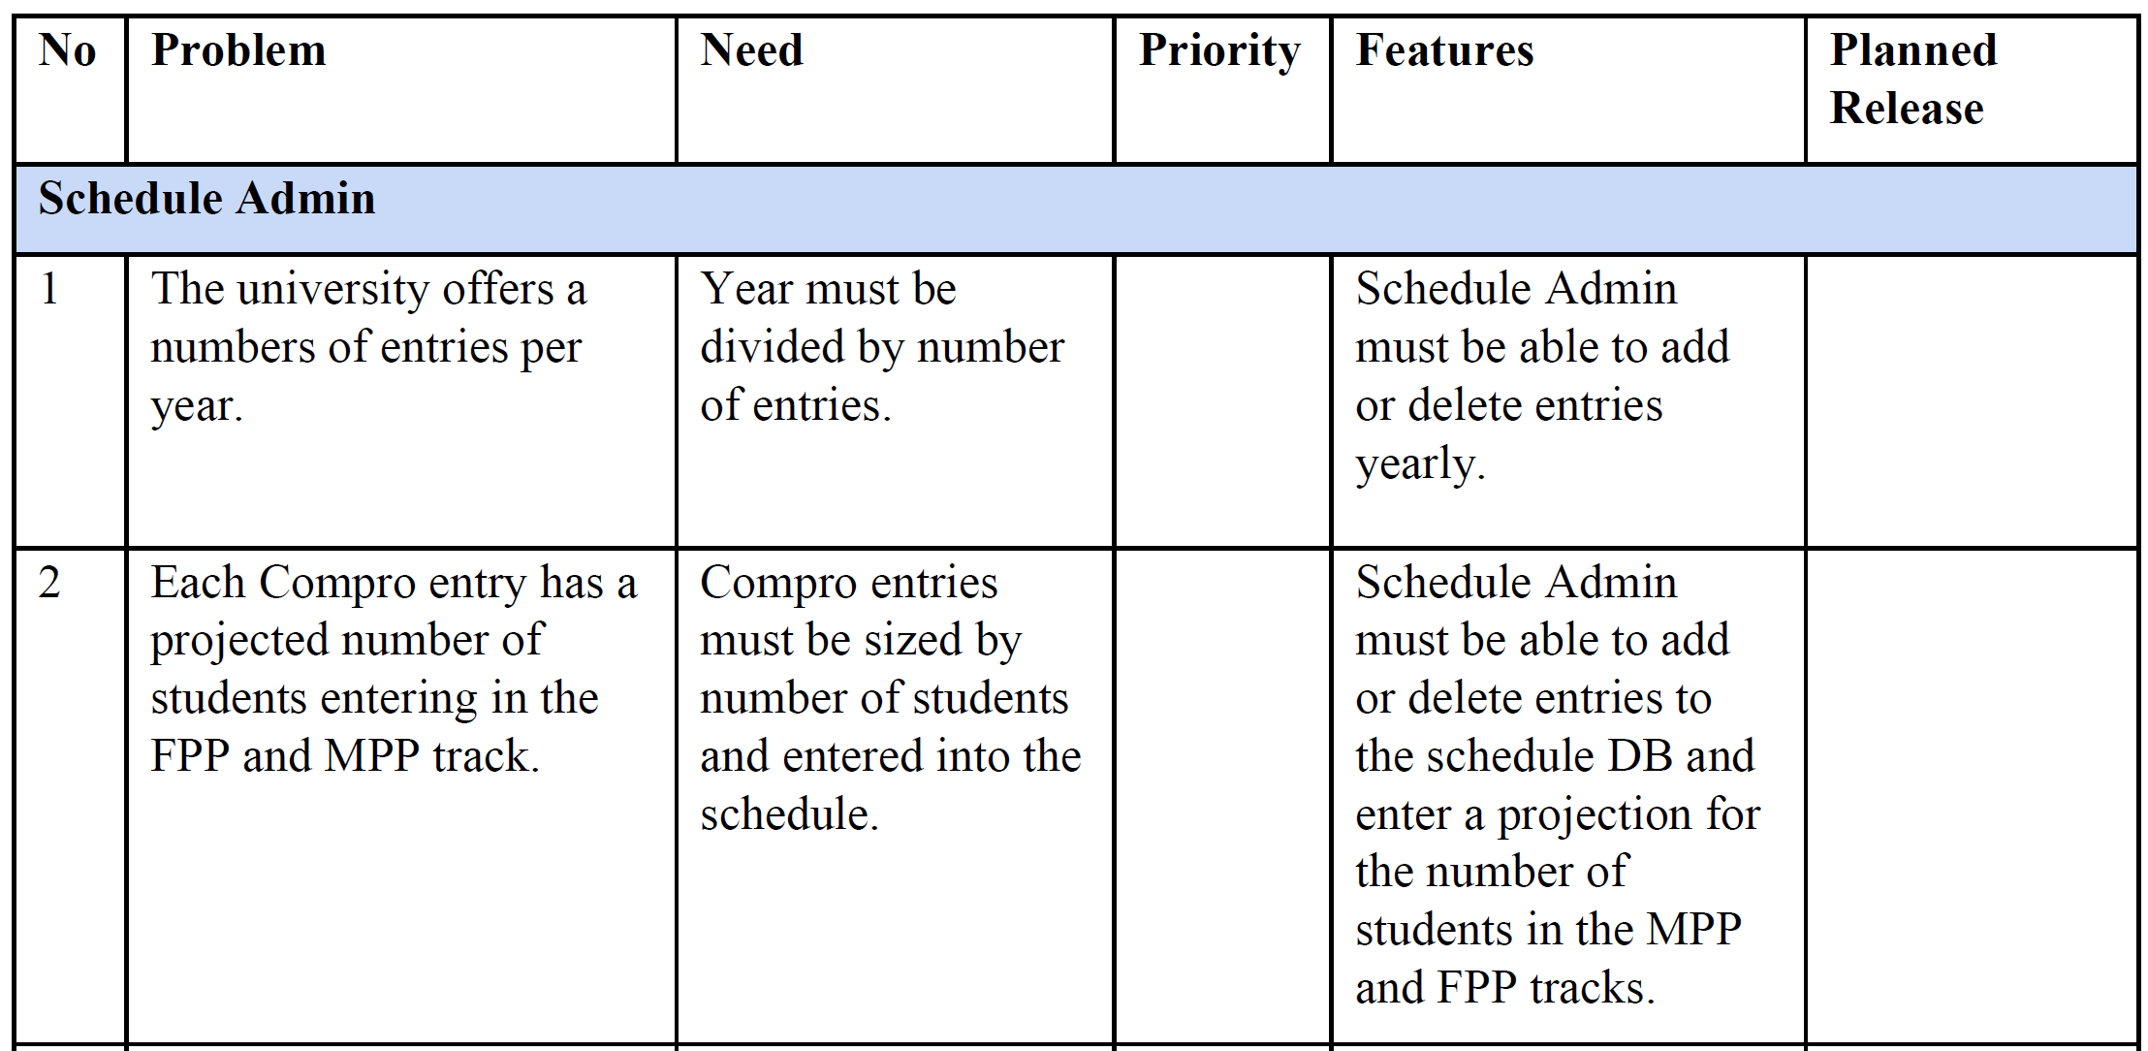

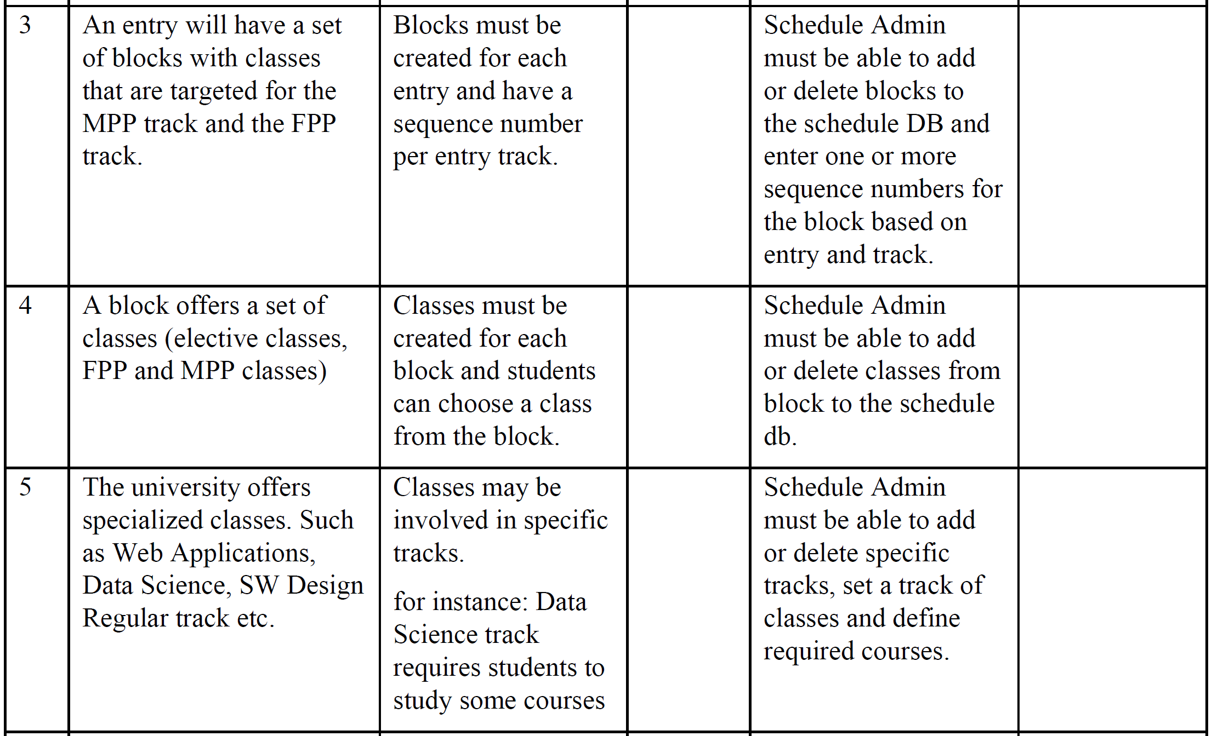

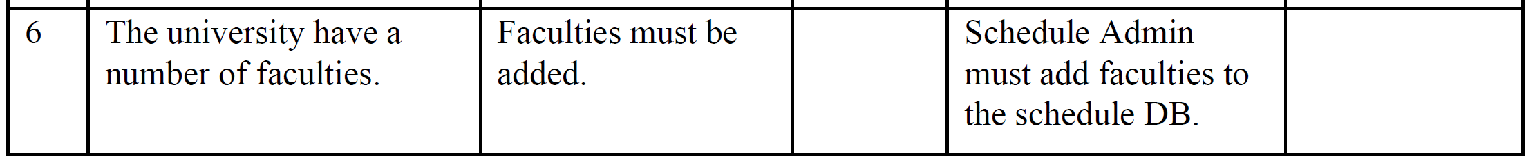

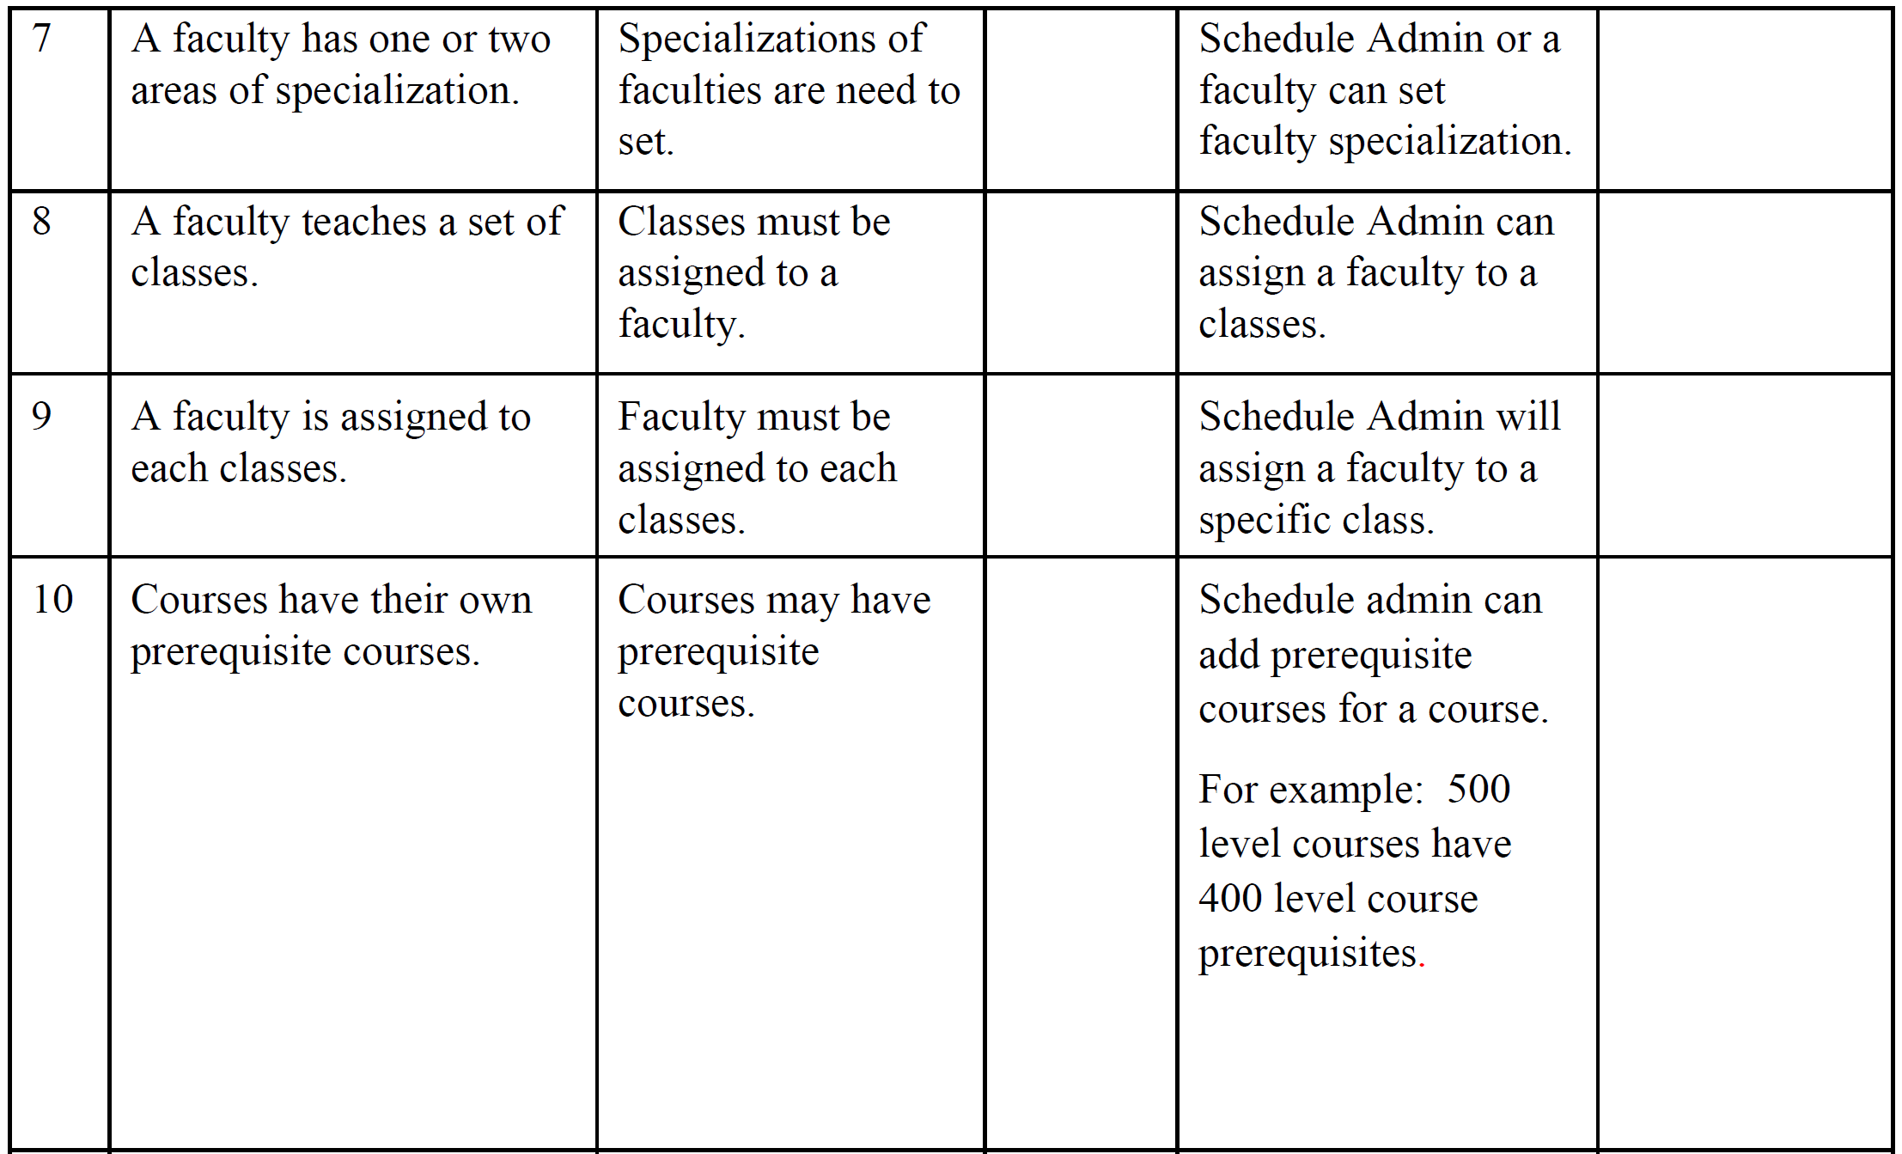

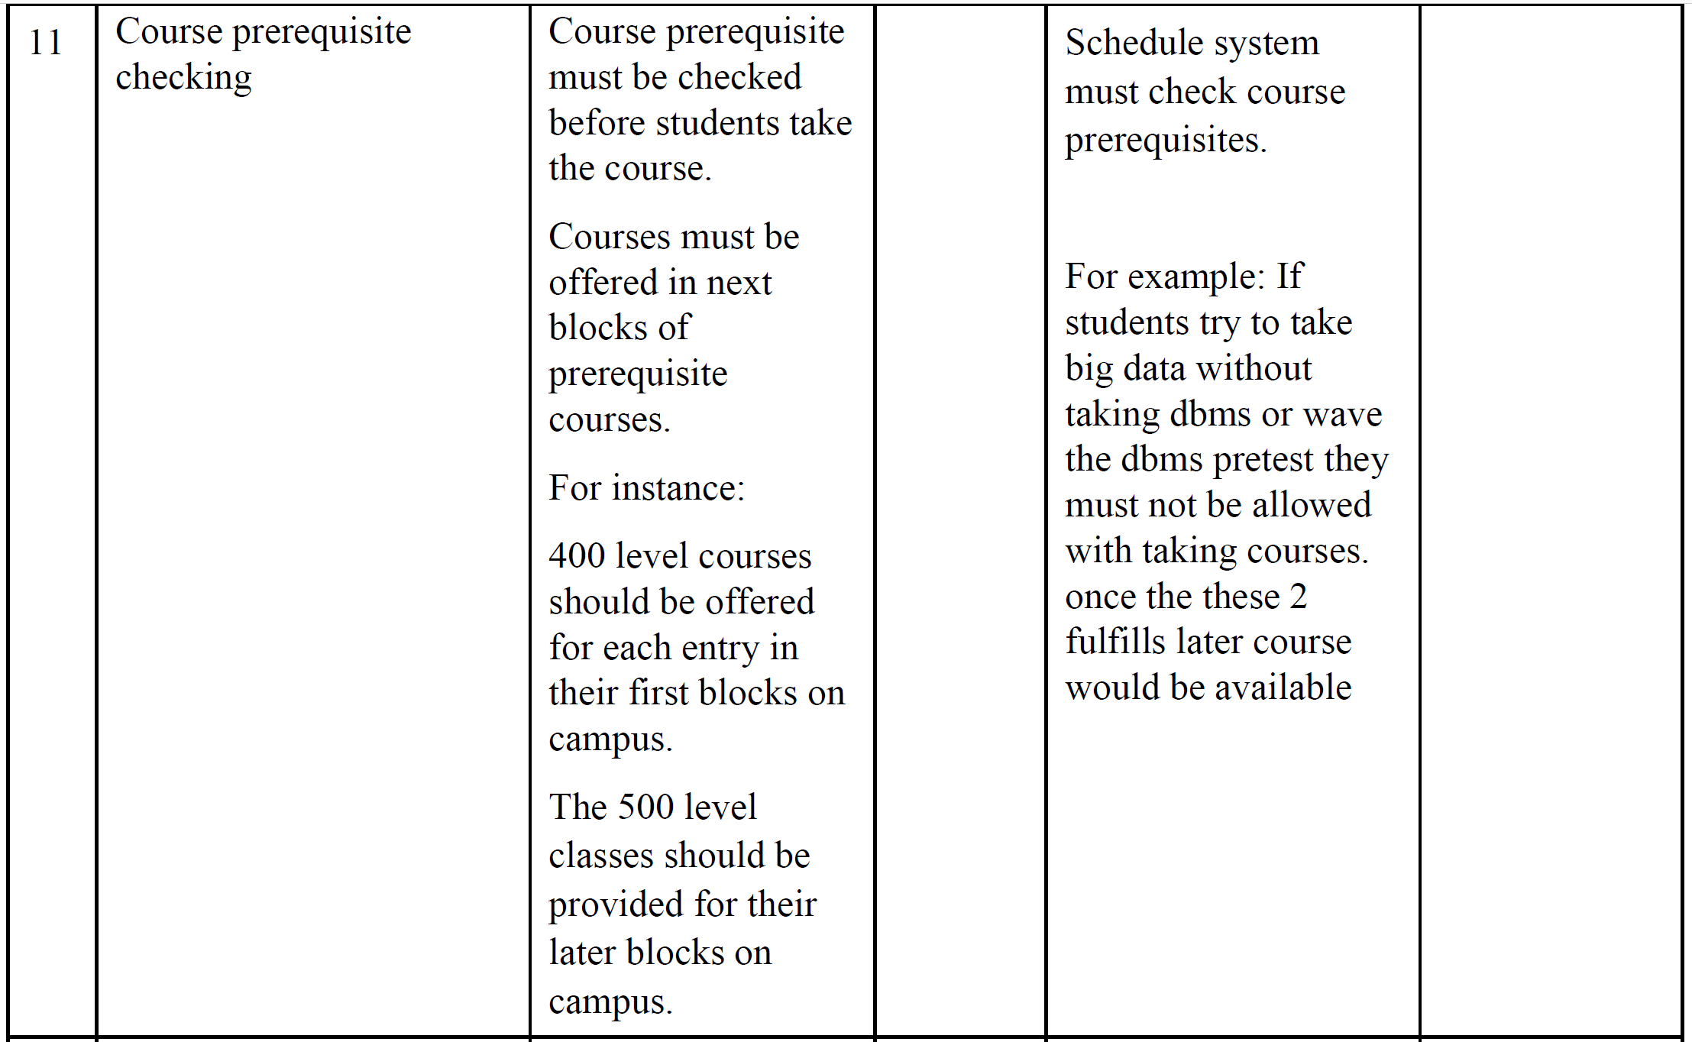

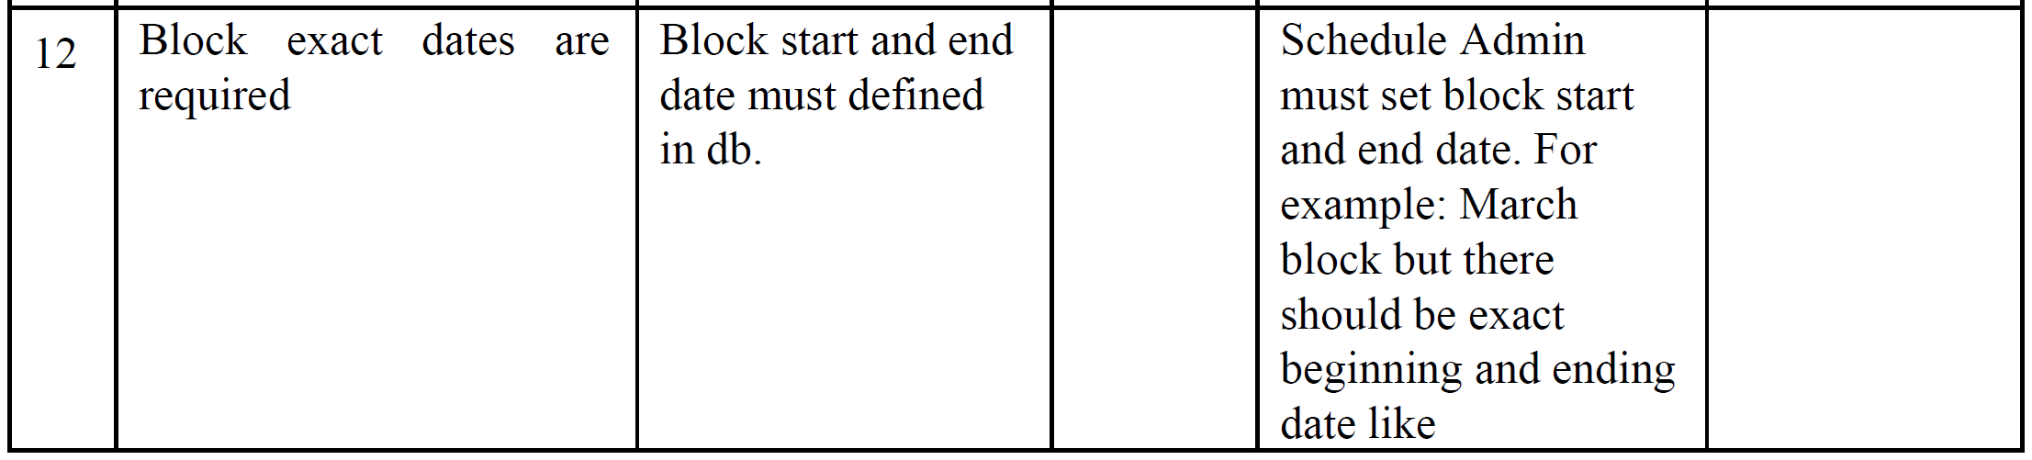

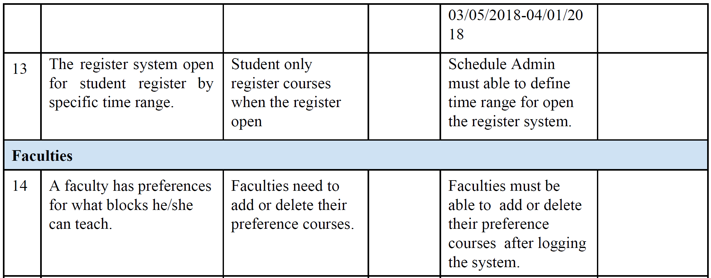

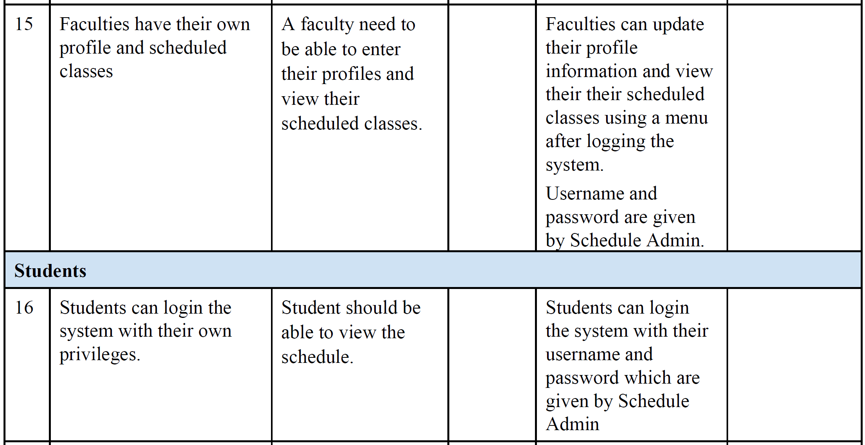

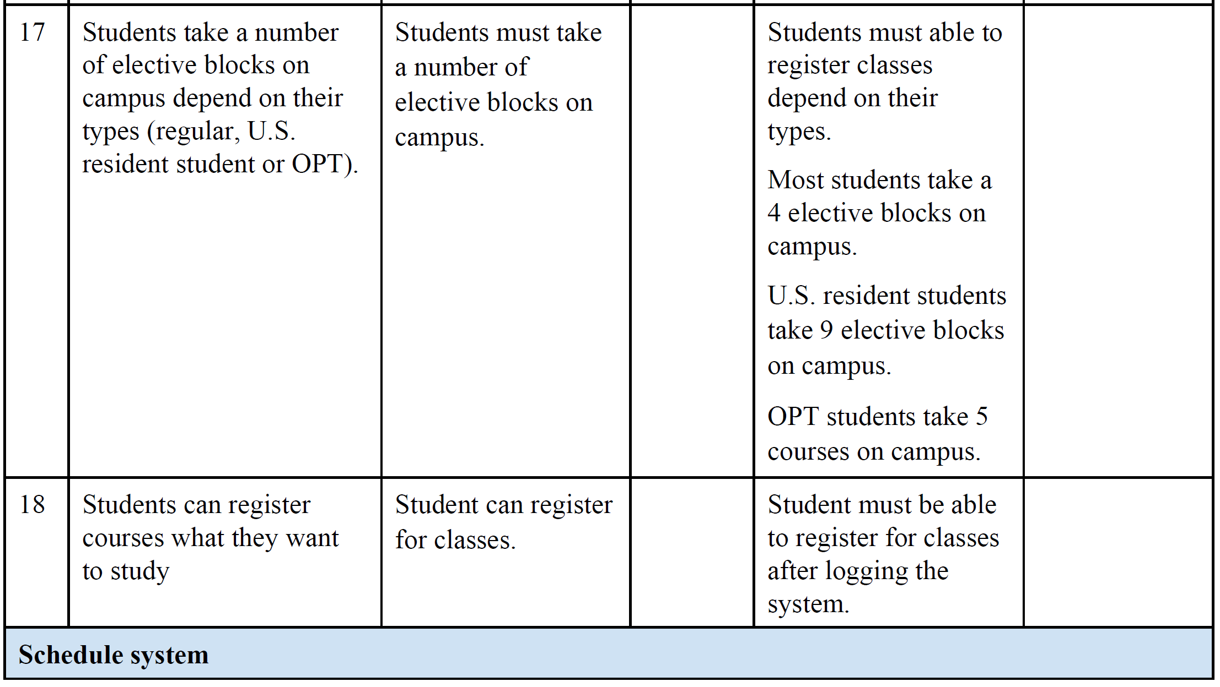

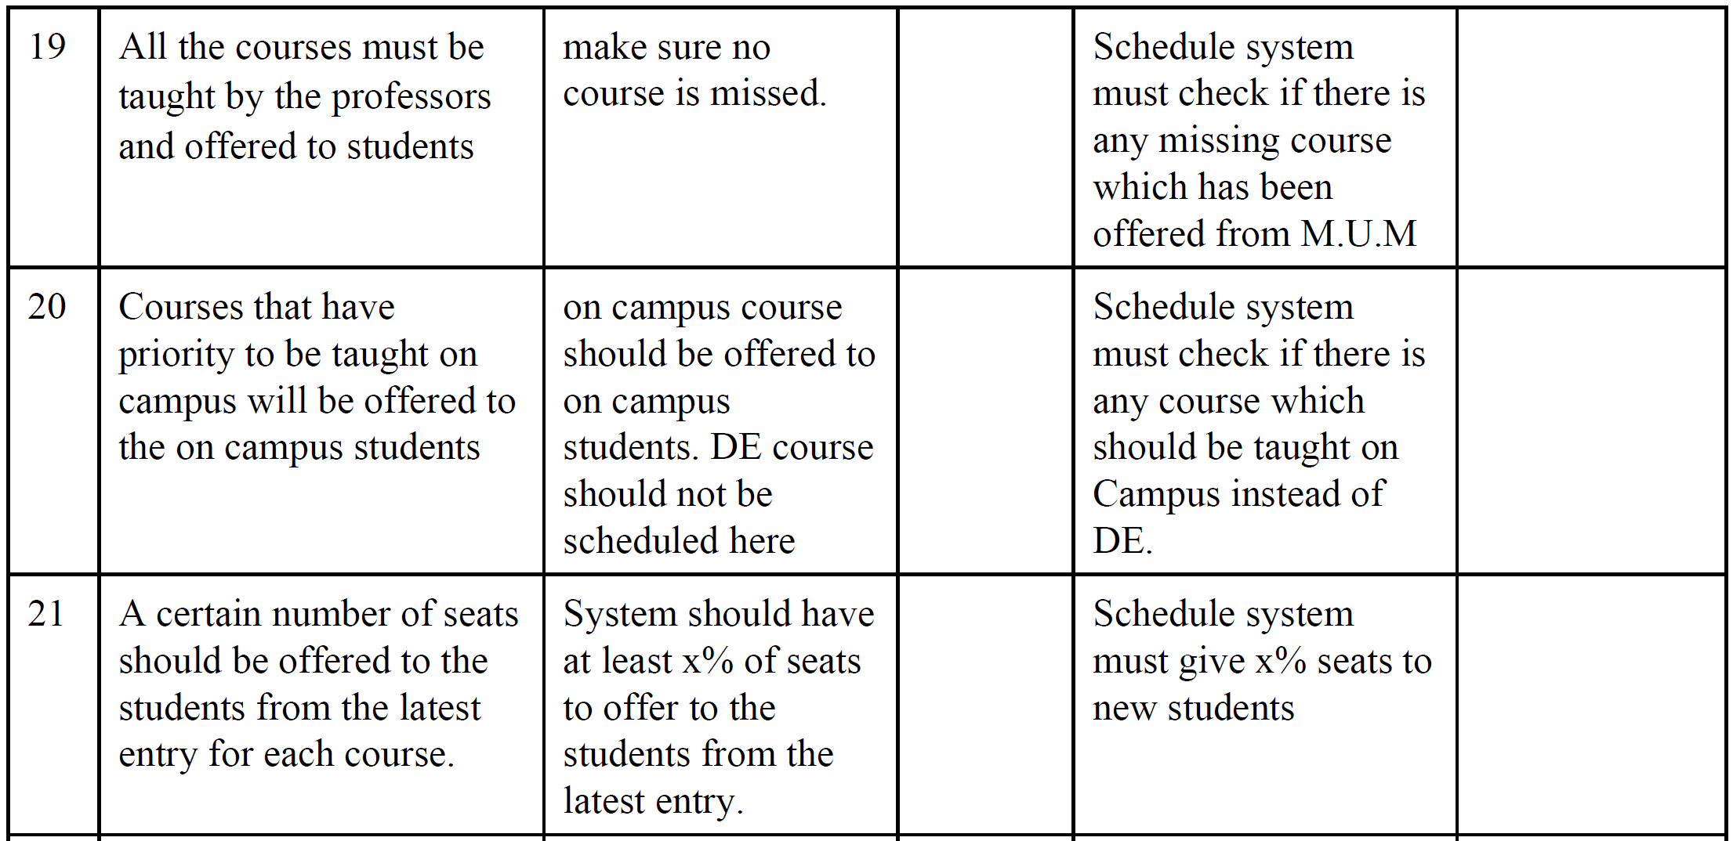

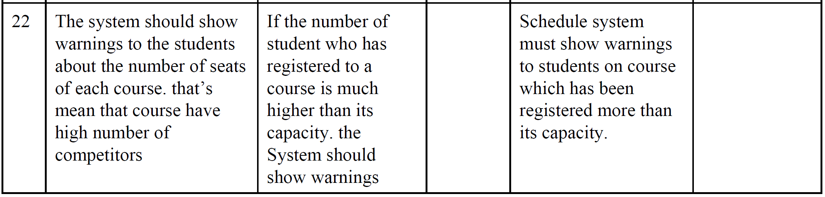

**4.4 Alternatives and Competition**

*[Identify alternatives the stakeholder perceives as available. These can include buying a competitor’s*

*product, building a homegrown solution, or simply maintaining the status quo. List any known competitive*

*choices that exist or may become available. Include the major strengths and weaknesses of each competitor*

*as perceived by the stakeholder or end user.]*

**5. Other Product Requirements**

*[At a high level, list applicable standards, hardware, or platform requirements; performance requirements;*

*and environmental requirements.*

*Define the quality ranges for performance, robustness, fault tolerance, usability, and similar*

*characteristics that are not captured in the Feature Set.*

*Note any design constraints, external constraints, or other dependencies.*

*Define any specific documentation requirements, including user manuals, online help, installation,*

*labeling, and packaging requirements.*

*Define the priority of these other product requirements. Include, if useful, attributes such as stability,*

*benefit, effort, and risk.]*